Environmental Protection Division

Transition in the size class distribution of pitch pine (Pinus rigida) and oak (Quercus spp.) in pine- and oak-dominated forest communities within the Long Island Central Pine Barrens.

Jordan Jessamy¹, Rebecca Rolnick¹, Joanna Lumsden-Pinto¹, Martin Dovciak¹, Kathy Schwager², Tim Green²
1 Environmental Protection Division, SUNY College of Environmental Science and Forestry, Syracuse, NY, 13210
2 Environmental Protection Division, Brookhaven National Laboratory, Upton, NY, 11973

Abstract
The Long Island Central Pine Barrens (LICPB) is an Atlantic coastal pine barren ecosystem comparable to only three other similar systems in the world. As the home to endangered and threatened species, and the aquifer that supplies Long Island’s drinking water, this ecosystem is protected under the Long Island Central Pine Barrens Protection Act. Nevertheless, forest health and tree population demography in LICPB have likely been impacted by invasive species, climate change, fire suppression, human development, and a lack of active management. This study aims to achieve a better understanding of the trajectory of pitch pine and oak populations in both pine- and oak-dominated communities by comparing their current size class structure to that documented in a previous survey in 2005/2006. We resurveyed 41 of the 93 plots in the summer of 2019 and collected data on the abundance of trees at different size classes ranging from 1 (seedling) to 5 (mature). Using Tukey's HSD Test, we found no significant difference was found in the abundance of size classes compared to 2005/2006, although in the 2019 survey oak seedlings were more abundant than pine seedlings in pine-dominant communities. Additionally, the results depict that a small number of oak and pine seedlings are recruiting to the sapling stage in both communities, warranting concern for future forest development. We recommend repeating the analysis in 2020 after data for the 93 plots is complete to verify the observed trends from the 2019 data. Future attention should be given both to monitoring upcoming oak dominance in pine forests and seedling success rates for pine and oak, and managing the LICPB so that pine seedling recruitment rates increase.

Introduction
The Long Island Central Pine Barrens (LICPB) is one of three rare Atlantic coastal pine barren ecosystems in the world, which are found only within New York, New Jersey, and Massachusetts (M.J. Jordan et. al., 2003). The LICPB is also home to a diversity of species, some endangered or threatened and dependent on certain vegetation found in this ecosystem (R. Forman, 2012). Additionally, the LICPB is also home to several forest communities; the ones of interest for this study can be categorized into pitch pine (Pinus rigida) dominated communities and oak (Quercus spp.) dominated communities (R. Forman, 2012; C. Reschke, 2014). The pitch pine dominated communities are pitch pine forest, pitch pine-oak forest, and pitch pine-scrub oak forest. The oak dominated communities consist of oak-pine forest and coastal oak forest (C.G. Lorimer and A.S. White, 2003; F.E. Kurczewski and H.F. Boyle, 2000; Latham et. al., 1996). Throughout these communities, the dominant species are typically those best adapted to fire and poor, droughty soils, including pitch pine (Pinus rigida), scrub oak (Quercus ilicifolia), and certain ericaceous shrubs including lowbush blueberry (Vaccinium angustifolium) and hillside blueberry (Vaccinium pallidum) (C.A. Copenhaver et. al., 2000; Latham et. al., 1996; M.J. Jordan, 2003; R. Forman, 2012). The poor, droughty soils are the result of glacial activities that deposited layers of disturbed loamy, sandy, and gravelly soil during the Pleistocene epoch. (Pine Barrens Commission, 2019; F.E. Kurzcewski and H.F. Boyle, 2000; R. Forman, 2012). The LICPB is also important from a societal perspective given that it feeds and maintains three major aquifers which are the sole source of drinking water on Long Island (L.F. Konikow, 2013; Nassau Suffolk Water Commissioners’ Association, 2019; Pine Barrens Commission, 2019; R. Forman, 2012).
Although the LICPB is protected under the Long Island Pine Barrens Protection Act (Pine Barrens Commission, n.d.; R. Forman, 2012), the 106,000 acres of forest have largely been fragmented (F.E. Kurzcewski and H.F. Boyle, 2000) due to land use changes that have caused the LICP to become an imperiled ecosystem (F.E. Kurzcewski and H.F. Boyle, 2000). The most significant land use changes include urbanization, logging, agriculture, and fire suppression, in conjunction with alterations in climate, hydrology, and outbreaks of plant disease (i.e. oak wilt) and invasive pests including southern pine beetle (Dendroctonus frontalis) and gypsy moth (Lymantria dispar dispar) (Kosiba et. al., 2018; Pine Barrens Commission, 2019; F.E. Kurzcewski and H.F. Boyle, 2000). Many of these climatic, edaphic, anthropomorphic, and disturbance factors have been shown to impact plant distributions (C.A. Copenhaver et. al., 2000) due to their effects on key seedling germination variables including litter depth, canopy cover, soil chemistry, moisture, herbivory, and competition from other plants. (S.L. Collins and R.E. Good, 1987). Deer overbrowsing is another potential threat to forest regeneration. There is an overpopulation of deer in Suffolk County, and the Central Pine Barrens Commission observed that deer herbivory prevented seedling recruitment during a ten-year monitoring study (USDA, 2014). All of the above factors taken together may be contributing to a shift in species demographics that may in the long term cause changes in forest canopy composition.
Three hypotheses for the potential ongoing changes in forest size class structure states of the forest types in the LICPB were developed (Figure 1). The three hypotheses are Ecosystem Collapse (EC), Increased Mortality and Recruitment (IMR), and Dense Canopies and Decreased Recruitment (DCDR). While the latter two hypotheses are more self-explanatory, the Ecosystem Collapse hypothesis is categorized by an all-around decrease in stems of all size classes over time. While shifts in the population demographics can be linked to factors including climate change and land-use legacies (Wason and Dovciak, 2017), the impact of the demographic shifts can be extensive and felt at multiple community scales across the landscape (Gurevitch et. al., 2016). Alterations to a population’s demographics can be detrimental to the welfare of both the population’s status through impacts on carrying capacity, growth rate, and extinction risk, and that of interacting plant and animal species (Gurevitch et. al., 2016). Overall, any change in a population’s demographics merits monitoring for the impact of the change on the overall health of the ecosystem.
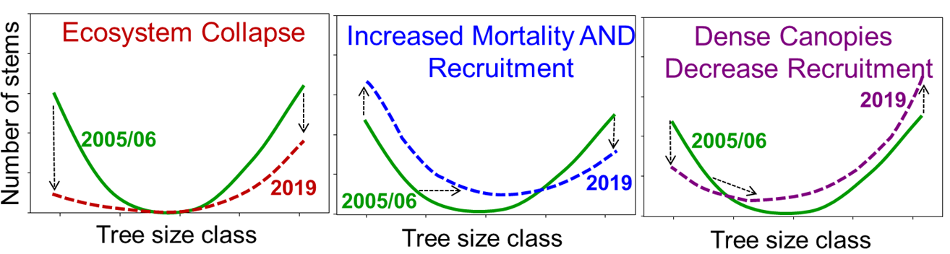
Figure 1: Three hypotheses regarding possibilities for change in size class distribution as a consequence of multiple stressors in LICPB ecosystem. Note that size classes and their distributions are based on the most recent (2005/2006) forest health monitoring survey at LICPB. Size classes ranged from 1 (seedlings) to 5 (mature trees > 10 cm DBH). Adapted from Dovciak et al. (2018).

This study aims to achieve a better understanding of the current and future trajectory of pitch pine and oak trees in both pine- and oak-dominated communities by comparing their respective size class abundances from a survey done in 2005/2006 to a partial resurvey done in 2019. The comparative analysis will also enable us to describe which of the three hypotheses may be the most fitting for each species type within each community type. Lastly, the study also aims to determine which (if any) of the species and community types may be experiencing the greatest changes in size class structure over time.
As a result of the recent, prolonged alterations in the disturbance regime of the LICPB, we expect to observe several transitions over the past 14 years. First, we hypothesize that the pitch pine size class distribution in pine dominated communities reflects an Ecosystem Collapse (EC hypothesis, Figure 1). This outcome is probably due to mortality from southern pine beetle infestation and decreased regeneration caused by both fire suppression and canopy cover from hardwoods. Pitch pine is a shade intolerant species that requires bare mineral soil and an open high-light environment for seedling germination; areas of dense canopy cover have been shown to reduce seedling success (Landis et al., 2005; Latham et. al., 1996; M.J. Jordan et. al., 2003; S. Little and Garrett, n.d.; S. Little, 1959; S. Little and Garrett, n.d.). Furthermore, pitch pine requires fire disturbance (R. Forman, 2012; S. Little and Garrett, n.d.; T.J. Givnish, 1981) . In the absence of fire, its serotinous cones are able to release seeds upon maturation (S. Little and Garrett, n.d.; T.J. Givnish, 1981), but for as much as 40% of pitch pine in certain community types, the cones will require fire to open (Landis et al., 2005; Latham et. al., 1996; M.J. Jordan et. al., 2003; N. Welch, 2000; S.L. Collins and R.E. Good, 1987; S. Little, 1959; S. Little and Garrett, n.d.; T.J. Givnish, 1981). Pine dominated communities are one successional stage in the pine barrens ecosystem, and without disturbance to create the conditions required for pine regeneration, the system will continue along the trajectory towards an oak-dominated community (F.E. Kurzcewski and H.F. Boyle, 2000; M.J. Jordan et. al., 2003; N. Welch, 2000; R. Forman, 2012).
In oak dominated communities, we expected to see that oak trees are facing Increased Mortality and Recruitment (IMR hypothesis, Figure 1). The spread of oak wilt, increased defoliation by gypsy moth caterpillars, and deer herbivory on seedlings and saplings has reduced oak’s health across all size class distributions (Kosiba et. al., 2018; R. Forman, 2012). However, due to fire suppression and the resulting decrease in pitch pine competition, we can predict that oaks are also witnessing increased recruitment.

Methods
SITE DESCRIPTION
Oak-Dominated Forest
The two oak-dominated communities selected for this study are similar to each other, but with some key differences. In both coastal oak and oak-pine forests, canopy cover is typically greater than 60% and dominated by oak trees including scarlet oak (Quercus coccinea), black oak (Quercus velutina ), white oak (Quercus alba), and less frequently chestnut oak (Quercus montana) (C. Reschke et. al., 2014; Michael S. Batcher et. al., 2007; R. Forman, 2012). Within the coastal oak forest, pitch pines tend to represent <10% of the canopy (Michael S. Batcher et. al., 2007), along with other species in low abundance, including sassafras (Sassafras albidum) (C. Reschke et. al., 2014). In contrast, in oak-pine forests the upper canopy is more stratified with pitch pine trees constituting up to 49% of the upper canopy and the lower canopy consisting of the oak species mentioned above (Michael S. Batcher et. al., 2007; R. Forman, 2012).
Understory in the coastal oak communities is variable (Michael S. Batcher, 2007); shrub layer density can be irregular between forests, although typically diverse with numerous heath shrubs (Michael S. Batcher, 2007). The dominant heaths are black huckleberry (Gaylussacia baccata), hillside blueberry (Vaccinium pallidum), and lowbush blueberry (Vaccinium angustifolium) (C. Reschke et al., 2014; Michael S. Batcher, 2007). Oak-pine communities typically have scattered scrub oak (Quercus ilicifolia) and heath shrubs in line with, and below, the scrub oaks (R. Forman, 2012). Two layers of shrub cover are formed, with the lower layer being fairly dense (Michael S. Batcher et. al., 2007; R. Forman, 2012). Both communities possess comparatively sparse herb layers consisting mostly of wintergreen (Gaultheria procumbens), Pennsylvania sedge (Carex pensylvanica), and eastern bracken fern (Pteridium aquilinum) (Michael S. Batcher et. al., 2007; R. Forman, 2012).

Pine-Dominated Forest
In the pitch pine forests, canopy cover consists mostly of pitch pine, yielding a minimum of 60% cover, with scattered scrub oak and continuous huckleberry and blueberry in the shrub layer (Michael S. Batcher et. al., 2007). Canopy cover in pine-oak forest is equally dense as pitch pine forests, but with pitch pine ranging between 50-89% cover (Michael S. Batcher et. al., 2007). The remainder usually consists of mostly white oak, black oak and scarlet oak (C. Reschke et. al., 2014; R. Forman, 2012). The understory of pine-oak forests is mixed with scrub oak and heath shrubs, with density often relative to the amount of canopy cover (C. Reschke et. al., 2014; Michael S. Batcher, 2007; R. Forman, 2012). In contrast, the understory of the pitch-pine scrub oak community, often located in more extreme soils (Michael S. Batcher et. al., 2007), largely consists of 60-80% scrub oak cover, in addition to various heaths, forbes, and dense grass patches (C. Reschke et. al., 2014). The density of the understory causes scattered pitch pine and oak to form only 59% or less of the canopy cover (C.Reschke et. al., 2014; Michael S. Batcher, 2007; R. Forman, 2012).
DATA COLLECTION
In 2005, the Long Island Central Pine Barrens Commission developed the Forest Health Monitoring Protocols to standardize the data collection across 93 permanent plots(16 m x 25 m) established randomly across the Long Island Central Pine Barrens. 50 of 93 previously established plots in randomly selected locations across the Long Island Central Pine Barrens were used for data collection. At each plot, a 16m x 25m transect is generated with markings placed at specific locations: one marker at each corner (M1, M3, M4, M6), one marker at each halfway point along the 16 m line (M2 and M5), and one marker placed in the center of the plot (CM) (Figure 2). To determine the abundance of seedlings and saplings for pitch pine and oak species belt transects were used along the 25 m side. A total of 4 belt transects were established starting from the M1-M6 line and spaced 2m apart, and only covered one half of the transect. The belt transects were used to measure abundance of trees in size class 1 (seedlings), size class 2 (saplings between 0.5 and 2.0 m tall), and size class 3 (saplings >2.0 m tall and <2.5 cm DBH). All living trees in size classes 4 (>2.5 cm and <10 cm DBH) and 5 (>10 cm DBH) in the plot were identified to species and diameter-at-breast-height (DBH; 1.3 m above ground) was measured.
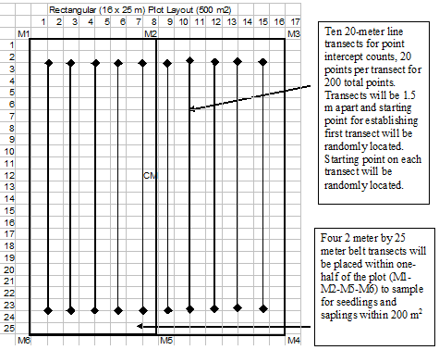
Figure 2. Overall plot layout of 16 x 25 meter plot (400 m²)

Data was first collected in each plot during 2005 and 2006, and then again in 2019, during the months of June-August. Due to the randomization of the plots and the absence of a community type map for the Pine Barrens when the plots were created, there are unequal sample sizes for both community types. Some plots needed to be removed due to no longer following the protocol’s parameters, and others for having been recently burned generating outliers. As a result, the sample size for pine-dominated communities and oak-dominated communities is 24 and 17, respectively.

DATA ANALYSIS
All the data collected using the protocol was entered into Microsoft Access, and the relevant data was exported to Microsoft Excel. The plot data was divided between the two community types, and then further divided by year. Prior to analysis, the seedling data for both pines and oaks in both community types needed to be modified due to inconsistencies in the data collection procedure for seedling abundance between 2005/2006 and 2019. Initially, seedlings were only tallied to a maximum of 11 per species per transect for each plot. In 2019, the seedling tally cap was removed. To resolve the difference in abundance values resulting from the change in procedure, the 2019 seedling data was modified to follow the 2005/2006 max seedling cap protocol.
Minitab was used to generate Probability Plots to test the normality of the data using the total species abundance values for each plot and each species’ size class in both community types (Appendix A). Excel was used to calculate the average abundance of each size class for each species within each community type for each year. The averages were then plotted on scatter plots to provide a comparative analysis of the size class distributions for the pine and oak trees in both community types (Figures 3-6).
Tukey's HSD Test was used to test a series of hypotheses. The first two tests were testing the null hypotheses that the size class abundance for both pitch pine and oak species respectively are not significantly different in 2005/2006 compared to the 2019 abundance values. Each test is representative of one of the two community types, with the former testing the hypothesis with respect to pine-dominated communities, and the latter focusing on oak-dominated communities. Using the same test, we tested the null hypotheses that the 2019 size class abundances for both pine and oak trees respectively were not significantly different between community types. All tests were conducted at a 95% confidence interval.

Results
We accept the null hypothesis from Tukey's HSD Test, in pine communities for both pitch pine and oak, that the 2019 size class abundances were not significantly different than the 2005/2006 size class abundances for all size classes. However, in 2019 oak seedling abundance showed to be significantly greater than pine seedling abundance within pine communities by an average of 5.71 to 28.7 seedlings. In the oak community, only the oak seedling abundance comparison yielded significant results. For oak seedlings, we reject the null hypothesis and can suggest that the current oak seedling abundance (36.35 + 27.53) is significantly greater than the 2005/2006 seedling abundance (18.35 + 21.95) by between 0.17 to 35.83 seedlings on average. A visual depiction of the size class abundance transition is available in Figures 3-6.
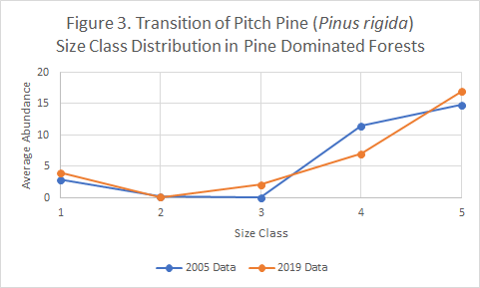
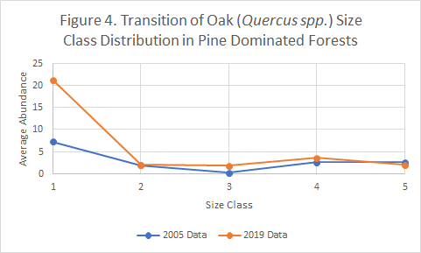
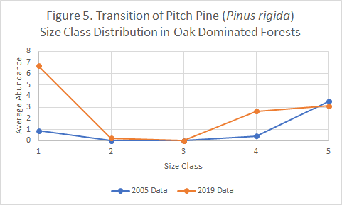
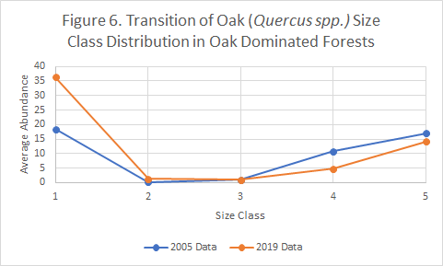
For the final test, in testing the null hypotheses that the size class abundances for pitch pine or oak species were significantly different between community types, we found that both pine and oak trees within size class 5 were significantly different between community types. Size 5 oak trees were significantly greater on average in the oak-dominated community (14.176 + 7.585) compared to pine-dominated communities (2.042 + 3.099) by 3.55 to 20.72 trees based on the confidence interval. Size 5 pine trees were found to be significantly greater in pine-dominated communities (16.917 + 13.909) than the oak-dominated community (3.118 + 3.480) by an average of 5.21 to 22.39 trees. The average abundance of each size class for both pine and oaks within oak-dominant and pine-dominant communities is available in Tables 1 and 2 respectively.

Table 1. Average Size Class Abundance for Pinus rigida and Quercus spp. in Oak Dominant Communities in 2005 and 2019 (n = 17)
 | Pine |  | Oak
Size Class | 2005 | 2019 | 2005 | 2019
1 | 0.9 | 6.7 | 18.4 | 36.4
2 | 0.0 | 0.2 | 0.2 | 1.2
3 | 0.0 | 0.0 | 0.9 | 0.9
4 | 0.4 | 2.6 | 10.8 | 4.8
5 | 3.5 | 3.1 | 17.1 | 14.2

Table 2. Average Size Class Abundance for Pinus rigida and Quercus spp. in Pine Dominant Communities in 2005 and 2019 (n = 24)
 | Pine |  | Oak
size class | 2005 Data | 2019 Data | 2005 Data | 2019 Data
1 | 2.9 | 4.0 | 7.3 | 21.2
2 | 0.2 | 0.1 | 1.4 | 2.0
3 | 0.0 | 2.0 | 0.3 | 1.8
4 | 11.4 | 7.0 | 2.5 | 3.6
5 | 14.8 | 16.9 | 2.5 | 2.0

Discussion
For several of the size classes, the abundance data is skewed due to the high presence of plots where trees of that particular size class were absent. As a result, the data suffers from zero inflation which may be in part responsible for the non-normality and evidenced by the probability plots for the different size classes in both community types and the high variation in all size classes. Software limitations prevented us from being able to employ measures to account for the inflation. Future work on this study should use the zero inflated negative binomial model or the hurdle negative binomial model (B. Pittman et al., 2018; M. Ridout et. al., 1998).
Additionally, for testing the null hypotheses that there is no significant difference between size classes for a particular species between community types, the results may also be impacted due to the unequal sample size of each community type causing a decrease in the power of the tests (S. Rusticus and C. Lovato, 2016). The overall sample size is also small since only 41 of the 93 plots were surveyed during the 2019 field season. In 2020, after data for the 93 plots is complete, the analysis can be repeated to disclose a more complete picture of the changes in demography. Additionally, the increased sample size may help to decrease the high variability and promote power.
For this study, only pitch pine and oak trees were considered; other species were not taken into consideration. In addition to pitch pine and oak species, other tree species that were present include red maple (Acer rubrum), black cherry (Prunus serotina), and sassafrass (Sassafras albidum) in some plots. Likewise, scrub oak (Quercus ilicifolia) was not considered because it is a shrub. However, scrub oak has been shown to have a significant effect on the regeneration of pitch pine seedlings by first enhancing and then inhibiting growth (Landis et. al., 2005) and therefore it plays a key role in forest regeneration dynamics. Since it is possible that these species could come to dominate some areas, or influence the development of the species of interest, not including these species could result in an incomplete view of the dynamics of forest demography as explained in Gurevitch et al. (2016).
This analysis of the size class structure gives us a basic idea of the state of the forest, but more research can be done to investigate the causes of what we observed. The seedlings alive in 2005 should have grown to full size classes 2 and 3, yet we found almost no saplings of that size. It is uncertain whether the survival of the seedlings is being inhibited by herbivory, competition, growth inhibition from ericaceous shrubs (A.U. Mallik, 1998), another cause, or an interaction of the listed options.

Conclusion
None of the initial hypotheses on changes in the mortality of mature trees (size class 5) and recruitment of seedlings (size class 1) were confirmed by our analyses due to a lack of significant changes. Based on our analysis, we can conclude that pine-dominated communities are not best represented by the Ecosystem Collapse hypothesis since we did not observe a significant decrease in mature pine trees as compared to 2005/2006, although there remains a paucity of seedlings. In oak-dominated communities, we predicted that “increased mortality and recruitment” would be the best hypothesis. There is a significant increase in oak seedling recruitment compared to 2005/2006, and while there is a slight decrease in the average number of mature oaks per plot, it is not statistically significant.
Based on the results of the size class charts, it is the success of seedlings to become saplings (size class 2 and 3) that may have the greater impact on forest demography over time compared to seedling recruitment. Since there are very few pitch pine seedlings in the pine-dominated forests, it is clear that the LICPB needs more management to promote the regeneration and maturation of pitch pine. Otherwise, pine-dominated forests may fail to persist as a distinct community type. Due to the highly variable survival odds of seedlings, pine trees produce large amounts of seeds (S. Little, 1959; S. Little and Garret, n.d.; R. Forman, 2012). Therefore, seedlings must be found in a much greater abundance than mature trees if they are to eventually replace the mature trees that are currently alive. Since this study did not focus on the relation of management or disturbance factors to size class abundances, several suggestions are presented:
- Prescribed burning is likely to help increase the abundance of pine seedlings and saplings by promoting the opening of the serotinous cones and creating soil conditions ideal for pitch pine germination and growth (S. Little and Garrett, n.d.; N. Welch, 2000). Additionally, fire may help pine forests persist in areas of southern pine beetle infestation (Knebel, 2007; Waldren, 2007). In a personal interview conducted with members of the Shinnecock Nation Environmental Department (S., 2019) it was stated that the Elders in their community remember the process they formerly used to conduct controlled burns. We recommend collaborating with knowledge holders in this community to develop management plans for controlled burns in the LICPB.
- Another method includes deer control. Deer population control may be beneficial if the mortality of seedlings and saplings is due to deer herbivory because an increased deer density has been shown to decrease the survival of woody seedlings to larger size classes (N.G. Tilghman, 1989).
- Oak thinning would reduce vegetation density, canopy cover, and aid in reducing pine seedling competition with oak seedlings. Since there is currently a significantly greater abundance of oak seedlings than pine in the pine dominated communities, they are likely to outcompete pine seedlings as they grow given their greater shade and density tolerances (S. Little, 1959). Future monitoring efforts should also focus on the survival ratio of the oak seedlings compared to pine seedlings in pine-dominated forests to determine the likelihood that a forest transition is occurring.
This research is important because this is the first time the plots in this long term monitoring study have been resurveyed, and the first opportunity we have had to observe a change. Since few of the differences observed between 2005/2006 and 2019 were statistically significant, we recommend repeating the analysis in 2020 after data for the 93 plots is complete. Should the plots continue to be resurveyed every 10 years, we expect a clearer picture will start to emerge. Understanding the forest dynamics in the Long Island Central Pine Barrens is key to making future forest health management decisions.

Acknowledgements
We would like to thank Joanna Lumbsden-Pinto, Martin Dovciak, Kathy Schwager and Tim Green for their help and guidance. Martin Dovciak developed the hypotheses we tested in this study. We would also like to thank the Central Pine Barrens Commission for their collaboration. This project was supported by the United States Department of Energy under the Science Undergraduate Laboratory Internships (SULI) program and Visiting Faculty Program (VFP), as well as by USDA McIntire-Stennis Program at the State University of New York College of Environmental Science and Forestry (SUNY-ESF). Last but not least, we extend our gratitude to the members of the Shinnecock Nation Environmental Department for meeting with us to learn about our research and discuss their knowledge of and cultural connections to the pine barrens.

Bibliography
A.U. Mallik, Environmental Forest Science 54, 309 (1998).
B. Pittman, E. Buta, S. Krishnan-Sarin, S.S. O’Malley, T. Liss, and R. Gueorguieva, Nicotine &
Tobacco Research (2018).
C.A. Copenheaver, A.S. White, and W.A.P. Iii, Journal of the Torrey Botanical Society 127, 19
(2000).
C.G. Lorimer and A.S. White, Forest Ecology and Management 185, 41 (2003).
C. Reschke, Ecological Communities of New York State, 2nd ed. (NY Natural Heritage Program,
2014).
Dovciak, M., T. Green, and K. Schwager (2018). Recent changes and future trajectories of an
ecosystem at the crossroads: Implications for planning, management, and conservation of Long Island Central Pine Barrens. USDA Forest Service McIntire-Stennis Research Proposal. SUNY-ESF, Syracuse, NY.
F.E. Kurczewski and H.F. Boyle, Northeastern Naturalist 7, 95 (2000).
J. Gurevitch, G.A. Fox, N.L. Fowler, and C.H. Graham, The Quarterly Review of Biology 91,
459 (2016).
L.F. Konikow, Scientific Investigations Report (2013).
Kosiba, G.W. Meigs, J.A. Duncan, J.A. Pontius, W.S. Keeton, and E.R. Tait, Forest Ecology and
Management 430, 94 (2018).
Landis, Matthew R., et. al. “Variation in recruitment and early demography in Pinus
rigida following crown fire in the pine barrens of Long Island, New York.” Journal of Ecology, vol 93, 2005, pp. 607-617.

M.J. Jordan, W.A. Patterson, and A.G. Windisch, Forest Ecology and Management 185, 151
(2003).
M. Ridout, J. Hinde, and C.G.B. Demetrio, International Biometric Conference (1998).
Michael S. Batcher, Robert R. Anderson, Ariana N. Breisch, Timothy M. Green, and Melanie J.
Theisen, (2007).
N. Welch, T. Waldrop, and E. Buckner, Forest Ecology and Management 136, 185 (2000).
Nassau Suffolk Water Commissioners’ Association. 2019
N.G. Tilghman, Journal of Wildlife Management 53, 524 (1998).
Pine Barrens Commission. 2018
R.E. Latham, J.E. Thompson, S.A. Riley, and A.W. Wibiralske, Bulletin of the Torrey Botanical
Club 123, 330 (1996).
R. Forman, Pine Barrens Ecosystem and Landscape(Elsevier Science, Burlington, 2012).
S. (2019, July 25). Update on the State of the Long Island Central Pine Barrens, Shinnecock
Nation Environmental Department. [Personal interview].
S.L. Collins and R.E. Good, Oikos 48, 89 (1987).
S. Little and Peter Garrett, Pínus Rígida Mí¡¡. USFS. (n.d.)
S. Little, Silvical Characteristics of Pitch Pine (Pinus Rigida) (Northeastern Forest Experiment
Station, Upper Darby, PA, 1959).
S. Rusticus and C. Lovato, Practical Assessment, Research, and Evaluation 19, (2014).
T.J. Givnish, Evolution 35, 101 (1981).
USDA, APHIS, Wildlife Services (2014). Long Island White-tailed Deer Damage Management
Demonstration Project Report.

